Project Method - Pulsatio Solutions

Team Members:

* Benjamin Zou - Graphic Designer - benjaminzou.bj@gmail.com
* Jeffrey W. Lakes - Graphic Designer - jeffrey.lakes.jr@gmail.com
* Cole Richwalls - Web Designer - crr11@students.ptcollege.edu
* Nate Pifer - Web Designer -nathanael.pifer@gmail.com
* David J Mardis - Project Manager - DavidJMardis@gmail.com

Team Biographies

* I am Jeff, a graphic designer who works at Pulsatio Solutions. Dependable, resilient and efficient are words that speak for my work. I enjoy rolling my sleeves up and making the perfect masterpiece. This includes, sifting through code itself, to having the opportunity to bring satisfaction through spectrums of design.I am on the chase after sharper, refined skills in an ever-growing field of study.
* I’m Ben, a graphic designer who works at Pulsatio Solutions. I am a creative thinker and a good listener. I am good at creating meaningful design solutions and enjoy challenges.
* I’m Cole, a web designer who works at Pulsatio Solutions. I am a devoted worker on making the best outcome for the job, I enjoy spending my time coding. I work with many different languages to make sure your web page is perfect.
* I'm Nathanel, a web designer who works at Pulsatio Solutions. I am hard working and can get the job done on time. I have a good understanding of many different coding languages to help get a great frame made for a page. I look forward to working with you on this project.
* I'm David, The Project Manager who works at Pulsatio Solutions. I have previous experience in creating web sites since I was the main designer and developer for the OakWheel Side by Side website. I am excited to work on new projects and can’t wait to hear from you!

Team Company Name:

* Pulsatio Solutions

Team’s Domain:

* pulsatioproductions.com

Team Company Logo: 

* Option1: option4:



* Option 2:

option:5

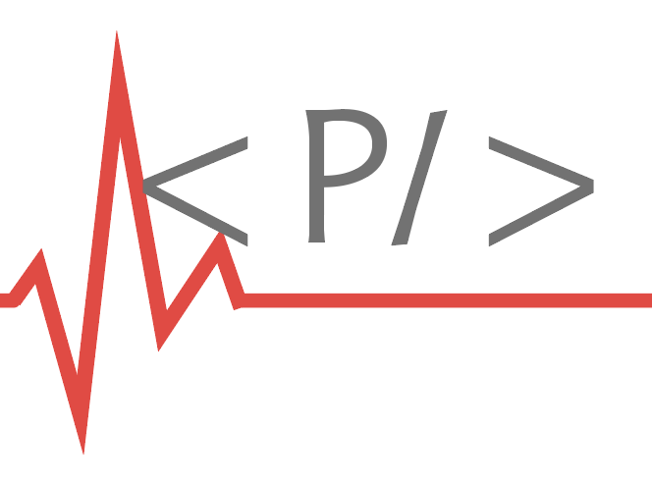



* Option 3:

option:6





* Option :7 option: 8 